个人简介 | 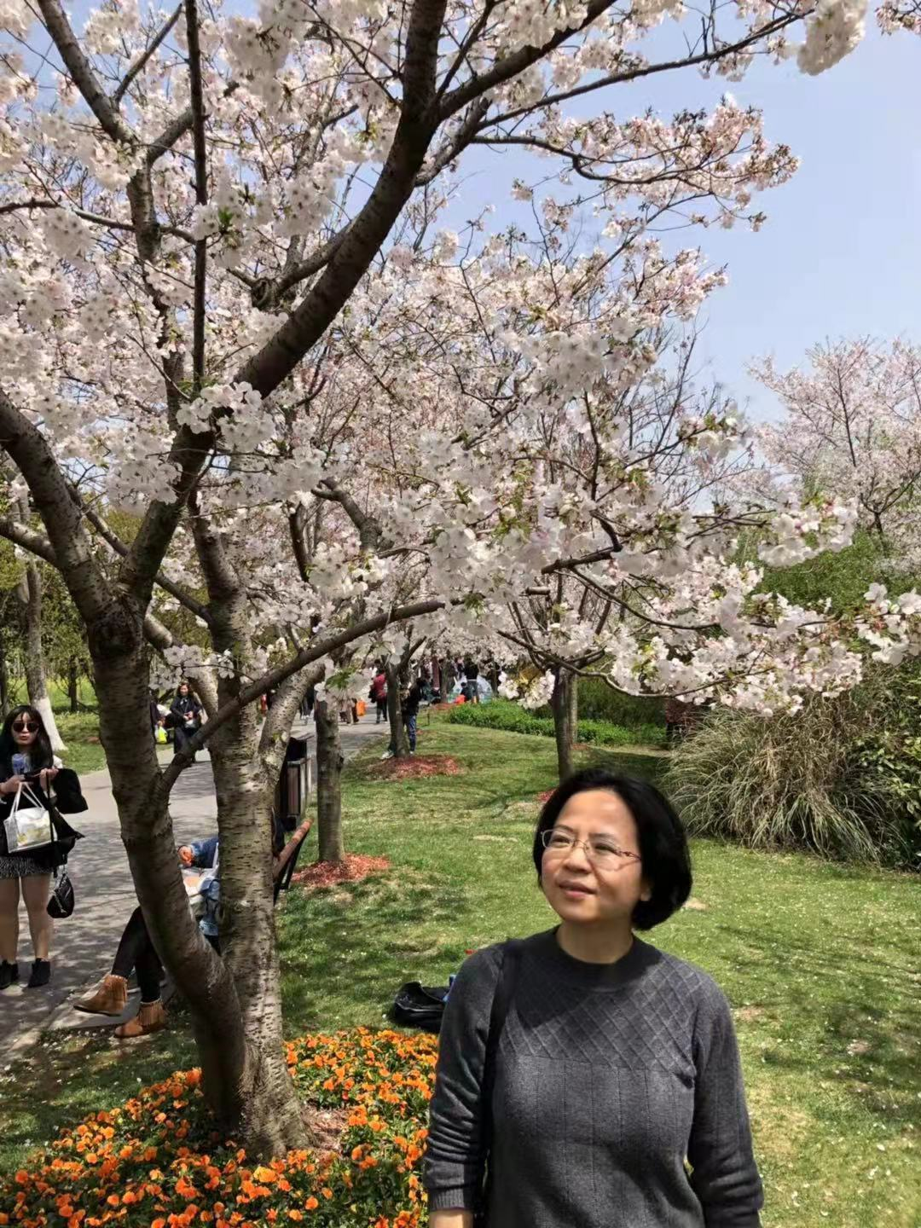
姓名：胡媛
性别: 女
出生年月：1976.7
学位/学历：博士/研究生
职称：研究员
电子邮件：huyuan@nipd.chinacdc.cn
办公地址：上海市黄浦区瑞金二路207号
教育经历
1994.9-1999.6 武汉大学医学院 临床医学专业 获学士学位
2002.9-2007.6 华中科技大学同济医学院病原生物学专业 硕博连读 获博士学位
工作经历
1999.7-2002.8 湖北黄石理工大学医学院 免疫微生物学 助教
2007.7-至今 中国疾病预防控制中心寄生虫病预防控制所（国家热带病研究中心） 研究员
2016.8-2016.12 美国密苏里大学哥伦比亚分校 访问学者
社会/学术任职和活动
2016.10 被聘为中国微生物学人兽共患病病原学专业委员会委员
2017.12 被聘为上海市寄生虫学会第十届理事会副秘书长
研究方向/主要研究内容
1.寄生虫与宿主相互作用机制的研究；
2.寄生虫疫苗的研制；
科研/教学研究项目
1.上海市自然科学基金面上项目“TIGIT+NK与MDSC细胞串化在血吸虫肝纤维化中的作用及其机制研究”，No.19ZR1462600，2019-2022.（主持）
2.国家传染病重大专项子任务“突发急性传染病寄生虫分离培养及筛选鉴定”，No.2018ZX10102001-002-004，2018-2020.（主持）
3.上海市自然科学基金面上项目“巨噬细胞内TLRs-NF-kB和NLRP3炎症小体共活化在抗血吸虫病机制中的作用研究”，No.14ZR1444200，2014-2017.（主持）
4.国家自然科学基金青年基金“建立免疫模型研究东方田鼠对血吸虫感染的天然抗性机制”No.30801047，2009-2011.（主持）
5.上海市公共卫生体系建设三年行动计划“重点学科建设”，No.GWV-10.1-XK13，2020-2022（参加）
6.国家公益性卫生行业科研专项“肉源性、水源性寄生虫病监测和风险评估关键技术研究”，No.201502021，2015-2018 （贾第虫诊断试条的研制）（参加）
7.传染病重大专项子课题“寄生虫类传染病病原体检测试剂评价用样品盘的建立”，No.2013ZX10004-805-007, 2013-2015（寄生虫诊断用标准品的研制）（参加）
主要学术成果
期刊论文
- Hu Y*﹟, Wang XL﹟, Wei YH, Liu H, Zhang J, Shen YJ, Cao JP*. Functional inhibition of natural killer cells in a BALB/c mouse model of liver fibrosis induced by Schistosoma japonicum infection. Front Cell Infect Microbiol. 2020, 10:598987.
- Sun L, Gong WC, Shen YJ, Liang L, Zhang XF, Li T, Chen TW, Hu Y*, Cao JP*. IL-17A-producing γδT cells promote liver pathology in acute murine schistosomiasis. Parasit Vectors. 2020, 13(1):334.
- Hu Y, Sun L, Yuan ZY, Xu YX, Cao JP*. High throughput data analyses of the immune characteristics of Microtus fortis infected with Schistosoma japonicum. Sci Rep. 2017, 7(1):11311.
- Hu Y, Xu Y, Lu W, Yuan Z, Quan H, Shen Y, Cao J*. De novo assembly and transcriptome characterization : novel insights into the natural resistance mechanisms of Microtus fortis against Schistosoma japonicum. BMC Genomics. 2014,15:417.
- Hu Y, Xu Y, Lu W, Quan H, Shen Y, Yuan Z, Zhang J, Zang W, He Y, Cao J*. Effects of Microtus fortis lymphocytes on Schistosoma japonicum in a bone marrow transplantation model. Exp Parasitol. 2014, 142: 27-37.
- Chen TT, Peng S, Wang Y, Hu Y, Shen Y, Xu Y, Yin J, Liu C, Cao J*. Improvement of mitochondrial activity and fibrosis by resveratrol treatment in mice with Schistosoma japonicum infection. Biomolecules. 2019, 9, 658; doi:10.3390/biom9110658
- Zheng L, Hu Y, Wang Y, Huang X, Xu Y, Shen Y*, Cao J*. Recruitment of neutrophils mediated by Vγ2 γδ T Cells deteriorates liver fibrosis induced by Schistosoma japonicum infection in C57BL/6 mice. Infect Immun. 2017,85(8):e01020-16.
- 魏玉环, 刘华, 李武军, 赵海, 胡媛*, 曹建平. 西藏阿里地区细粒棘球蚴人体分离株nad1基因多态性分析.中国寄生虫学与寄生虫病杂志. 2020, 38(1): 17-21.
- 王晓玲, 胡媛*, 徐馀信, 刘华, 曹建平. 日本血吸虫感染小鼠肝脏和脾脏淋巴细胞及其表面程序性死亡配体1表达动态变化的研究. 中国寄生虫学与寄生虫病杂志. 2018, 36(6): 579-585.
- 胡媛, 孙磊, 徐馀信, 曹建平. 东方田鼠肝内巨噬细胞的分离和鉴定.中国血吸虫病防治杂志. 2015, 27(3):282-284.
荣誉及奖项
- 2007-2009获 上海市公共卫生系统“三年行动计划”优秀青年人才项目资助。
- 2016年获得上海市卫健委优秀党务工作者称号

Profile
Name：Yuan Hu
Gender：Female
Date of birth：1976.7
Degree：Ph.D.
Title：Researcher
Email：huyuan@nipd.chinacdc.cn
Address：207 Ruijin Er Road, Shanghai, China
Education
1994.9-1999.6 Wuhan University School of Basic Medical Science, Clinical Medicine Science, Bachelor
2002.9-2007.6 Tongji Medical College of Huazhong University of Science and Technology, Pathogen biology, PhD
Appointments
1999.7-2002.8 Medical College of Hubei Polytechnic University, Immunology and Microbiology, Teaching assistant
2007.7-up to now Chinese Center for Disease Control and Prevention National Institute of Parasitic Disease, Researcher
2016.8-2016.12 University of Missouri, Columbia, USA, Visiting scholar
Academic Participation and Activities
2016.10 employed as a member of the Professional Committee of zoonosis of Chinese Microbiology
2017.12 employed as deputy secretary general of the 10th Council of Shanghai Parasitology Society
Research Interest
1. To study on the relationship between parasite and host.
2. To develop vaccines against parasitic diseases.
Projects
1.The General Project of Shanghai Natural Science Foundation“Study on the role and mechanism of TIGIT+NK and MDSC cell cascade in liver fibrosis induced by schistosoma japonicum infection”, No.19ZR1462600，2019-2022.（Project leader）
2.The Subtasks of National Infectious Diseases Major project“Isolation, culture, screening and identification of parasites induced emergent infectious diseases”, No.2018ZX10102001-002-004，2018-2020.（Project leader）
3.The General Project of Shanghai Natural Science Foundation“Study on the role of TLRs-NF-kB and NLRP3 inflammatory bodies co-activation in macrophages in anti-schistosomiasis mechanism”，No.14ZR1444200，2014-2017.（Project leader）
4.Youth Fund of the National Natural Science Fund project“The establishment of immunological model to study the natural resistance mechanism of Microtus fortis infected with schistosoma japonicum”No.30801047，2009-2011.（Project leader）
- 5.Three-year plan for developing a public health system “Construction of key Disciplines”, No. GWV-10.1-XK13，2020-2022 (Participation)
6.The National Special Research Fund for Non-Profit Sector“Research on key technologies for surveillance and risk assessment of flesh-borne and water-borne parasitic diseases”，No. 201502021，2015-2018 （Participation）
7.The Sub-project of Major Projects for Infectious Diseases“Establishment of sample tray for pathogen detection reagent evaluation of parasitic infectious diseases”，No.2013ZX10004-805-007, 2013-2015（Participation）
Publications
- Hu Y*﹟, Wang XL﹟, Wei YH, Liu H, Zhang J, Shen YJ, Cao JP*. Functional inhibition of natural killer cells in a BALB/c mouse model of liver fibrosis induced by Schistosoma japonicum infection. Front Cell Infect Microbiol. 2020, 10:598987.
- Sun L, Gong WC, Shen YJ, Liang L, Zhang XF, Li T, Chen TW, Hu Y*, Cao JP*. IL-17A-producing γδT cells promote liver pathology in acute murine schistosomiasis. Parasit Vectors. 2020, 13(1):334.
- Hu Y, Sun L, Yuan ZY, Xu YX, Cao JP*. High throughput data analyses of the immune characteristics of Microtus fortis infected with Schistosoma japonicum. Sci Rep. 2017, 7(1):11311.
- Hu Y, Xu Y, Lu W, Yuan Z, Quan H, Shen Y, Cao J*. De novo assembly and transcriptome characterization : novel insights into the natural resistance mechanisms of Microtus fortis against Schistosoma japonicum. BMC Genomics. 2014,15:417.
- Hu Y, Xu Y, Lu W, Quan H, Shen Y, Yuan Z, Zhang J, Zang W, He Y, Cao J*. Effects of Microtus fortis lymphocytes on Schistosoma japonicum in a bone marrow transplantation model. Exp Parasitol. 2014, 142: 27-37.
- Chen TT, Peng S, Wang Y, Hu Y, Shen Y, Xu Y, Yin J, Liu C, Cao J*. Improvement of mitochondrial activity and fibrosis by resveratrol treatment in mice with Schistosoma japonicum infection. Biomolecules. 2019, 9, 658.
- Zheng L, Hu Y, Wang Y, Huang X, Xu Y, Shen Y*, Cao J*. Recruitment of neutrophils mediated by Vγ2 γδ T Cells deteriorates liver fibrosis induced by Schistosoma japonicum infection in C57BL/6 mice. Infect Immun. 2017,85(8):e01020-16.
- Wei YH, Liu H, Li WJ, Zhao H, Hu Y*, Cao JP. Investigation and analysis of genetic polymorphism of Echinococcus granulosus in Ali region of Tibet.Chin J Parasitol Parasit Dis. 2020, 38(1): 17-21.
- Wang XL, Hu Y*, Xu YX, Liu H, Cao JP. Dynamic changes of lymphocyte differentiation and PD-L1 expression in mice infected with Schistosoma japonicum. Chin J Parasitol Parasit Dis. 2018, 36(6): 579-585.
- Hu Y, Sun L, Xu YX, Cao JP. Isolation and identification of macrophages from liver of Microtus fortis.Chin J Schi Contl. 2015, 27(3): 282-284.
Honors and Awards
1. 2007-2009, obtained the Excellent Young Talents Project of the Three year action plan of Shanghai public health system.
2. 2006, obtained the title of Excellent Party Affairs Worker of Shanghai Municipal Health Commission

